**CHAPTER 4**

**EXPERIMENTAL RESULTS AND DISCUSSION**

**4.1 INTRODUCTION**

In this chapter, description of the results obtained through the proposed model. The working of the model is detailed in this chapter. MATLAB is the software used to implement the proposed model. The diagnosis method consists of four stages, pre-processing of MR images, feature extraction, and classification.

**4.2 EXPERIMENT**

We need to design a low frequency antenna which doesn’t have any side effects and low power consumption we choose microstrip patch antenna because of its body wearing type and light weight. As it is said in Chapter 1 Microstrip antenna are easy to design and fabricate. The feeding method we used is the co-axial feed which is easy to feed a microstrip antenna and probably the best method to feed a low frequency microstrip patch antenna. We have done the experiment in CST Software, which is commonly used for Antenna design.

**4.2.1 ANTENNA ERROR CHECK**

Before Starting the stimulation of the antenna with the human head we should ensure that there is no error in it. Thus it this method is used to eliminate the error in the antenna.

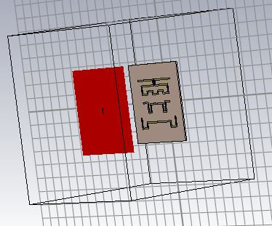

**Fig 4.1 STIMULATED ANTENNA**

The microstrip patch antenna is designed and stimulated as shown in the figure below and the S-parameters of the microstrip patch antenna is the output required to find the working status of the microstrip patch antenna.

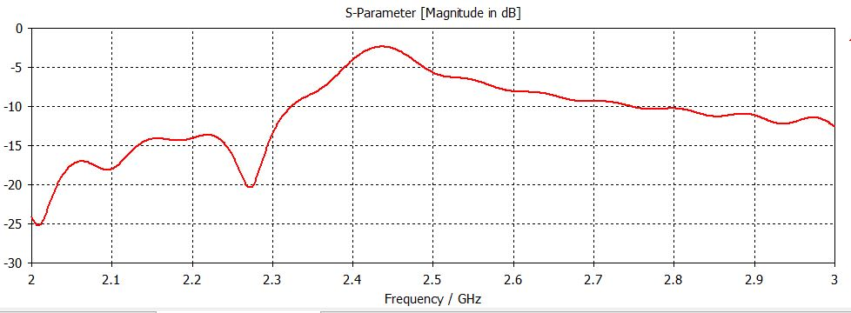

**Fig4.2 S PARAMETER GRAPH**

**4.2.2. SAM PHANTOM WITHOUT TUMOUR**

Now the working microstrip patch antenna is placed near the human head at a distance of 60mm, to achieve the maximum radiation intensity of the microstrip antenna. The image given below is the Sam phantom without tumor.

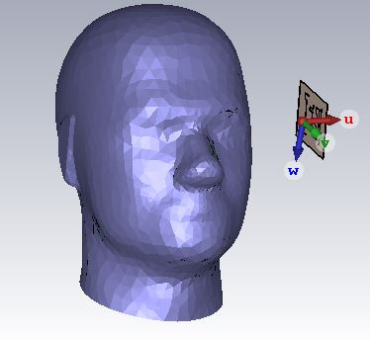

**Fig. 4.3 SAM PHANTOM WITHOUT TUMOUR**

The S-Parameter is given below is the graph that is generated by stimulating the file.

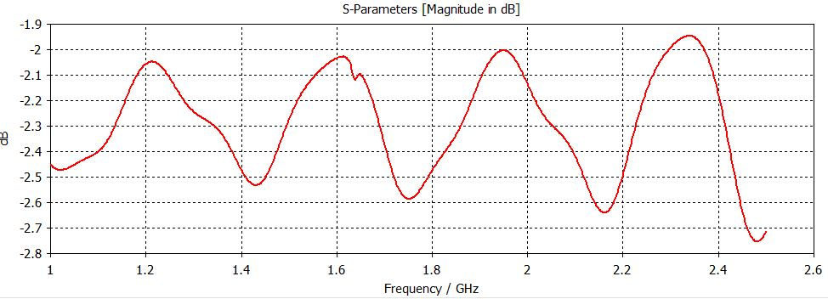

**Fig4.4 SAM PHANTOM WITHOUT TUMOR S-PARAMETER GRAPH**

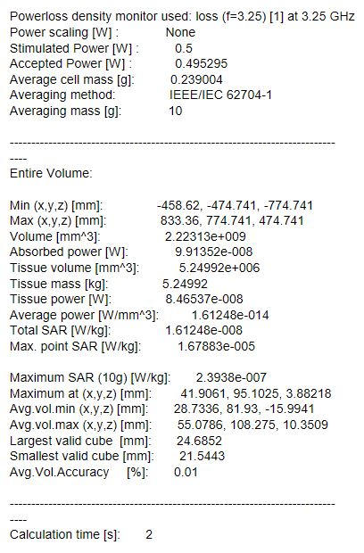

The above shown values are generated as a report by the CST file when stimulated. Maximum point Specific Absorption Rate is the required value for the identification of presence of tumour is the brain.

**4.2.3 SAM PHANTOM WITH TUMOUR**

The working microstrip patch antenna is placed near the human head at a distance of 60mm, to achieve the maximum radiation intensity of the microstrip antenna. The image given below is the Sam phantom with tumour.

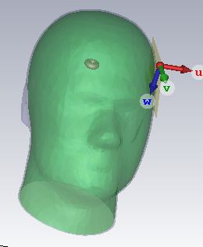

**Fig. 4.5 SAM PHANTOM WITH TUMOUR**

The S-Parameter is given below is the graph that is generated by stimulating the file.

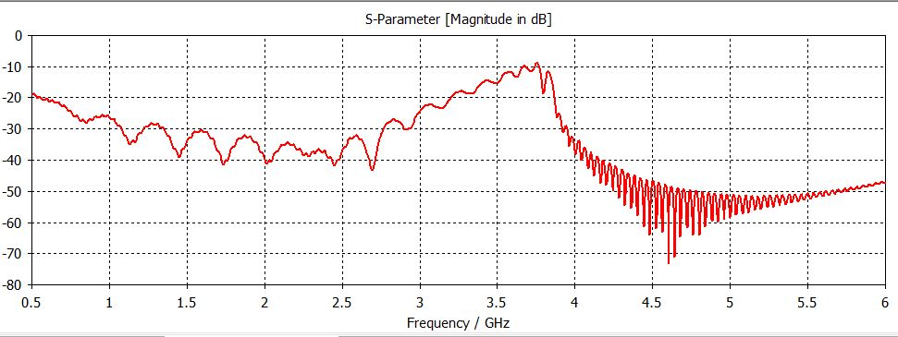 **Fig4.6 SAM PHANTOM WITH TUMOR S-PARAMETER GRAPH**

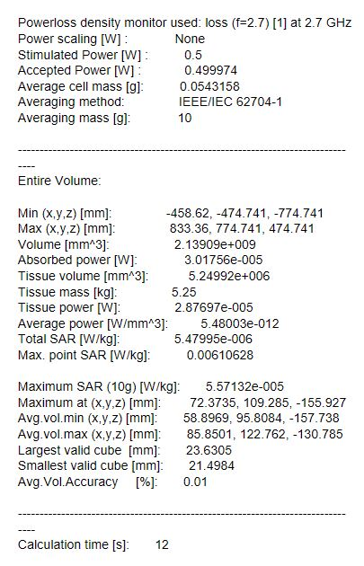

The above shown values are generated as a report by the CST file when stimulated. Maximum point Specific Absorption Rate is the required value for the identification of presence of tumour is the brain.

**4.3 FABRICATED ANTENNA**

**4.3.1 FRONT VIEW OF ANTENNA**

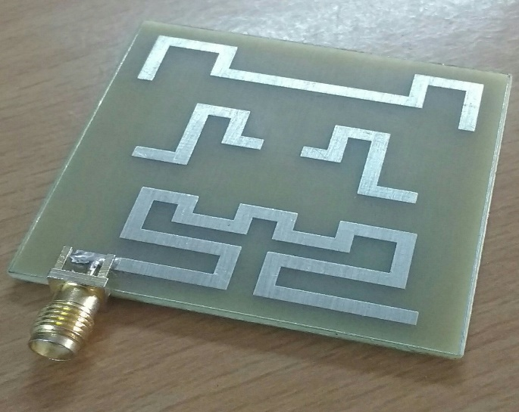

**Fig. 4.7 FRONT VIEW OF ANTENNA**

The above picture shows the front view of the fabricated antenna.

**4.3.2 BACK VIEW OF ANTENNA**

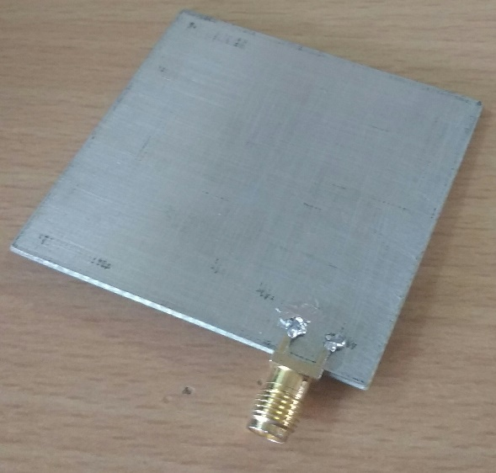

**Fig. 4.8 BACK VIEW OF ANTENNA**

**4.4 RETURN LOSS**

As we connect the network analyser with our microstrip antenna we get the return loss of our antenna. The below shown image is the return loss of the microstrip patch antenna we have designed.

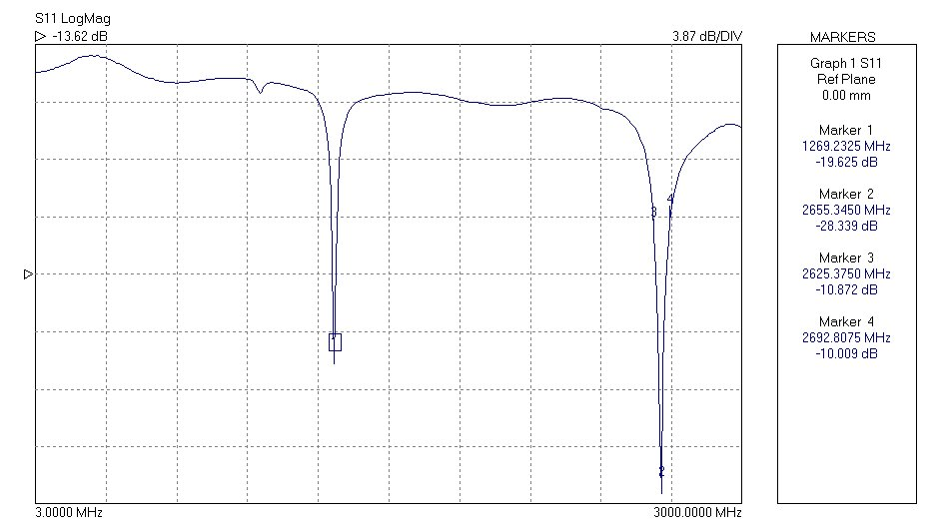

**Fig. 4.9 RETURN LOSS GRAPH**

|  |  |  |
| --- | --- | --- |
| **Frequency**  **(MHz)** | **Magnitude** | **Phase Shift** |
| 242.76 | 1.10879 | -123.70 |
| 250.2525 | 1.07951 | -127.94 |
| 257.745 | 1.0796 | -132.28 |
| 265.2375 | 1.10211 | -136.72 |

**Tab. 4.1 RETURN LOSS TABLE**

**4.5 PHASE**

By the same method we use to generate the return loss of the antenna we can also generate the phase of the microstrip patch antenna. The below shown image is the phase of the microstrip patch antenna we have designed.

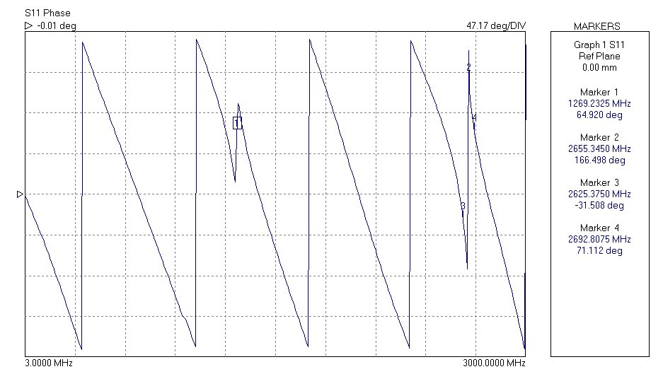

**Fig.4.10 PHASE SHIFT GRAPH**

**4.6 SMITH CHART**

By connecting the microstrip antenna with the network analyser, we can easily find the Smith Chart for our Antenna and its properties. The below shown image is the image of the smith chart for our microstrip patch antenna.

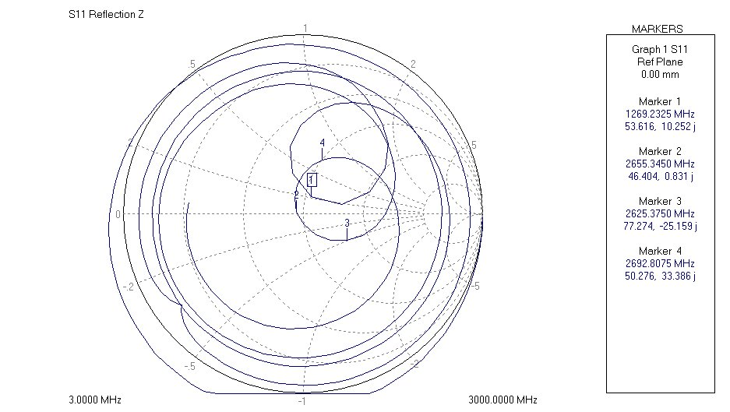

**Fig. 4.11 SMITH CHART GRAPH**

**4.7 SWR**

As soon as we finish connecting our microstrip patch antenna with the network analyser we can start the antenna operation and perform the SWR calculations of it.

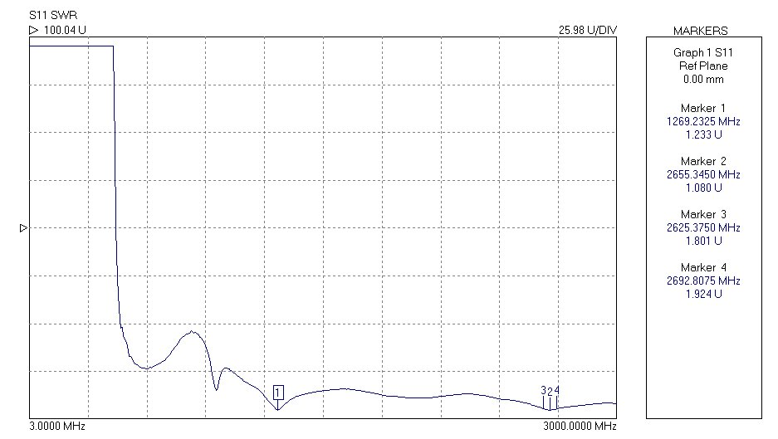

**Fig.4.12 SWR GRAPH**